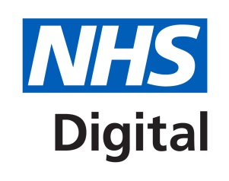
IGT v14.1 – email message for SIGN contacts

Subject line: IG Toolkit – 2017/18 and future requirements

Good morning,

We recently advised that discussions were ongoing regarding IG Toolkit submissions for 2017/18.

The requirements are now agreed and health and care organisations should complete version 14.1 as necessary.

Version 14.1 is due for release on Wednesday 5 July following final testing and will support anticipated submissions in October and March.

There are no substantive changes to requirements in version 14.1 from version 14.

Please note that v14.1 is an interim solution pending the introduction of a redesigned Information Governance Toolkit - as recommended in the National Data Guardian’s Review of Data Security, Consent and Opt-outs, and based around assuring local implementation of the ten data security standards set out in that review.

This redesigned IG toolkit is in phased development and will include a new set of mandatory requirements to support the evolving system and threats.

It will be more accessible and easier to use, while also providing a greater emphasis on data security leadership obligations – people, processes and technology.

A beta version of the redesigned toolkit is due for launch in the Autumn ahead of a formal roll out across all sectors in April 2018.

We will contact you again in due course to release a ‘statement of requirements’ to assist organisations in preparing evidence for the revised solution.

In the meantime, all organisations who currently complete the IG Toolkit must complete a v14.1 submission as outlined.

Yours sincerely,

Information Governance
NHS Digital

